**++Design Thinking Project Workbook**

**Don't find customers for your product but find products for your customers**

**1. Team**

**Intelligent Meal Planner Using Machine Learning**

**Team Name:**   
AI-Powered Meal Planner

**Team Members:**

1. [A.Harshavardini, LEADER,2320030346
2. [N.Tidiksha, ANALYST,2320030394]
3. [R.Bhanuz, PROJECT MANAGER, 2320030260]

**2. Problem/Opportunity Domain**

**Domain of Interest:**

**E-commerce and Online Retail**

**Description of the Domain: A brief overview of the key elements, challenges, and opportunities within the domain.**

The domain of **intelligent meal planning using machine learning** focuses on using AI to help people choose healthy and personalized meals. It involves key elements like user preferences, dietary needs, and nutritional values. The main challenges include handling diverse food choices, allergies, and changing user habits. However, there are great opportunities to improve health, save time, reduce food waste, and make better diet decisions through smart and adaptive meal recommendations.

**Why did you choose this domain?: The personal or strategic reasons for selecting this domain, such as passion, market potential, or solving a specific problem.**

I chose this domain because I’m passionate about health and technology. Many people struggle with planning healthy meals, so using machine learning can make it easier and smarter. It also has great market potential and can help solve real-life problems like poor diet, time management, and food waste.

**3. Problem/Opportunity Statement**

**Problem Statement:**

Many people find it difficult to plan healthy, balanced meals that fit their dietary needs, preferences, and busy lifestyles. Manual meal planning can be time-consuming and often leads to poor nutrition choices or food waste. There is a need for an intelligent system that can automatically suggest personalized meal plans using machine learning, helping users eat better, save time, and improve overall health.

**Problem Description:**

Meal planning is a daily challenge for many people due to time constraints, lack of nutritional knowledge, and varying dietary needs. People often struggle to choose meals that are healthy, budget-friendly, and suited to their preferences. Traditional methods of planning meals are not personalized and can lead to unhealthy eating habits or food wastage. By using machine learning, we can create a smart system that understands user needs and suggests personalized meal plans, making healthy eating easier and more effective.

**Context (When does the problem occur):**

The problem happens when people try to plan meals but don’t have enough time, nutrition knowledge, or ideas for healthy and tasty options.

**Alternatives (What does the customer do to fix the problem):**

To solve the problem, people often follow diet charts, use meal planning or fitness apps, search for recipes online, or consult nutritionists. However, these options may not always be personalized, convenient, or adaptable to changing needs.

**Customers (Who has the problem most often): The primary group of individuals or organizations affected by the problem.**

The primary users affected are busy individuals, health-conscious people, fitness enthusiasts, and those with specific dietary needs like diabetics, vegans, or people with food allergies. Families and working professionals also face this problem regularly.

**Emotional Impact (How does the customer feel):**

Customers often feel stressed, confused, and overwhelmed when trying to plan meals. They may feel frustrated by the lack of time, unsure about making healthy choices, and guilty when they fail to stick to a proper diet.

**Quantifiable Impact (What is the measurable impact):**

Poor meal planning can lead to increased health issues (e.g., obesity, diabetes), higher food waste, and more money spent on unhealthy food. It also wastes time spent searching for recipes or deciding what to eat. A smart solution can reduce food waste by up to 30%, save hours weekly, and improve diet quality significantly.

**Alternative Shortcomings (What are the disadvantages of the alternatives):**

Most alternatives are not fully personalized, can be time-consuming, and may not adapt to changing preferences or health goals. Diet charts can be too generic, apps may lack accuracy, online recipes aren't tailored, and consulting a nutritionist can be costly and inconvenient.

**Link to showcase the problem:**

<https://www.hsph.harvard.edu/nutritionsource/healthy-eating-plate/>

**3. Addressing SDGs**

**Relevant Sustainable Development Goals (SDGs): Identify which of the 17 SDGs are directly impacted by the problem or opportunity.**

**Goal 8:** Good Health and Well-being

**Goal 12:** Responsible Consumption and Production

**How does your problem/opportunity address these SDGs?: Describe how solving the problem or leveraging the opportunity will contribute to achieving one or more SDGs.**

By ensuring the integrity of product reviews, we promote fair competition and informed consumer choices, contributing to economic growth and responsible consumption practices.

**4. Stakeholders**

Answer these below questions to understand the stakeholder related to your project

1. **Who are the key stakeholders involved in or affected by this project?**

* End Users
* Food Industry Players
* Tech Developers
* Government & NGOs

1. **What roles do the stakeholders play in the success of the innovation?**

* **End Users:** People like students, working adults, families, and those with health or diet needs who use the meal planner to choose daily meals easily and healthily.
* **Food Industry Players:**Grocery stores, meal delivery services, and food brands that could integrate with or benefit from the platform.
* **Tech Developers:** Software engineers, data scientists, and ML developers involved in designing, building, and maintaining the intelligent meal planner.
* **Government & NGOs:** Organizations focused on public health, nutrition, and sustainability that may support or promote such tools in community programs.

1. **What are the main interests and concerns of each stakeholder?**

* **End Users:** Easy ,healthy meals and Accuracy ,privacy
* **Food Industry Players:** Promote products
* **Tech Developers:** Build smart system and data
* **Government & NGOs:** Public health and cost

1. **How much influence does each stakeholder have on the outcome of the project?**

* **High Influence:** E-commerce Platforms, Regulatory Bodies.
* **Moderate Influence:** Businesses/Sellers.
* **Low Influence:** Consumers.

1. **What is the level of engagement or support expected from each stakeholder?**

* **E-commerce Platforms:** High engagement expected for implementation.
* **Businesses/Sellers:** Moderate support; may require incentives.
* **Consumers:** Passive engagement; feedback-driven.

1. **Are there any conflicts of interest between stakeholders? If so, how can they be addressed?**

Potential conflicts may arise between e-commerce platforms want to maintain a large volume of reviews and the need to ensure their authenticity. Addressing this requires transparent policies and collaboration.

1. **How will you communicate and collaborate with stakeholders throughout the project?**

Regular updates, user feedback sessions, and collaborative workshops will be essential for maintaining stakeholder engagement.

1. **What potential risks do stakeholders bring to the project, and how can these be mitigated?**  
   Stakeholders may resist change due to concerns over costs or complexity. Mitigation strategies include clear communication of benefits and phased implementation.

**5. Power Interest Matrix of Stakeholders**

**Power Interest Matrix: Provide a diagrammatic representation of Power Interest Matrix**

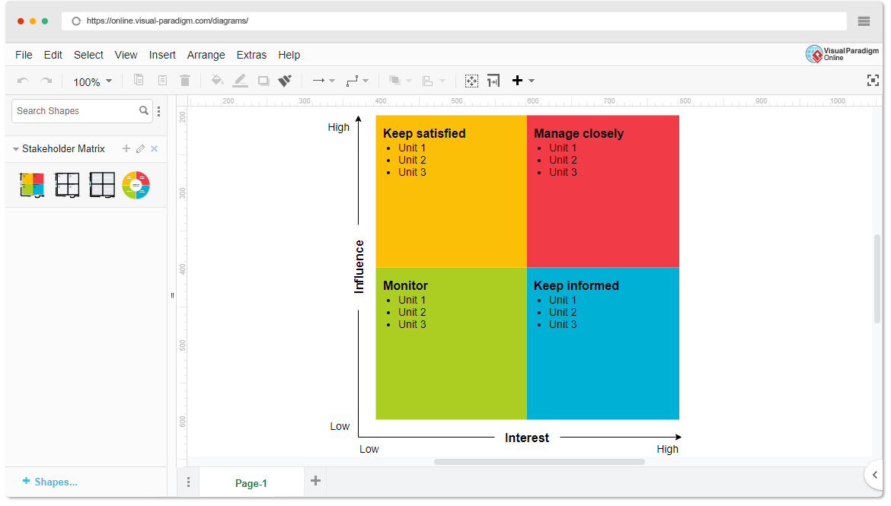

* High Power, High Interest: [E-commerce Platforms]
* High Power, Low Interest: [Businesses/Sellers]
* Low Power, High Interest: [Regulatory Bodies]
* Low Power, Low Interest: [Consumers]

1. **Empathetic Interviews**

**Conduct Skilled interview with at least 30 citizens/Users by asking open ended questions (What, why/How etc) and list the insights as per the format below**

| **I need to know**  **(thoughts, feelings, actions)** | **Questions I will ask**  **(open questions)** | **Insights I hope to gain** |
| --- | --- | --- |
| Thoughts | What do you think about online reviews? | | Understanding of consumer perceptions about the reliability of reviews. | | --- | |  | |
|  | Why do you trust certain reviews over others? | | Insights into factors that influence trust in reviews. | | --- | |  | |
|  | How do you decide which products to buy based on reviews? | | Awareness of decision-making processes related to reviews. | | --- | |  | |
| Feelings | How do you feel when you find a fake review? | | Emotional impact of encountering fake reviews. | | --- | |  | |
|  | Why is it important for you to see real reviews? | | Understanding the value consumers place on authenticity. | | --- | |  | |
|  | What emotions do you experience when a product doesn't meet your expectations after reading reviews? | | Insights into disappointment and frustration levels. | | --- | |  | |
| actions | What steps do you take if you suspect a review is fake? | | Understanding of consumer behaviour when faced with suspicious reviews. | | --- | |  | |
|  | How do you verify the authenticity of reviews before making a purchase? | | Awareness of methods used to check for genuine reviews. | | --- | |  | |
|  | What do you do if you have a bad experience with a product that had good reviews? | Insights into consumer responses to misleading information. |

**SKILLED INTERVIEW REPORT**

**(Examples are given. Erase them and fill with your user information.)**

| **User/Interviewee** | **Questions Asked** | **Insights gained (NOT THEIR ANSWERS)** |
| --- | --- | --- |
| Abhishek Verma,  Student | Which party do you vote for? | Citizens are not very open about their political preferences |
| Srinivasan P., Parent | How do you feel about the plans for a new capital? | Some citizens are sad that the capital is being relocated from Hyderabad. |
|  |  |  |
|  |  |  |
|  |  |  |

**Key Insights Gained:**

* **Insight 1**

These systems don't just look for obvious fake words. They use computers to understand how people write, and to notice when something seems off, like if a bunch of reviews sound too similar, or if someone's writing style changes a lot.

* **Insight 2**

The point of these systems is to make sure the reviews you read are real. This helps you know if a product is actually good, and it keeps companies from tricking you with fake praise.

**Empathy Map**

1. **Empathy Map**

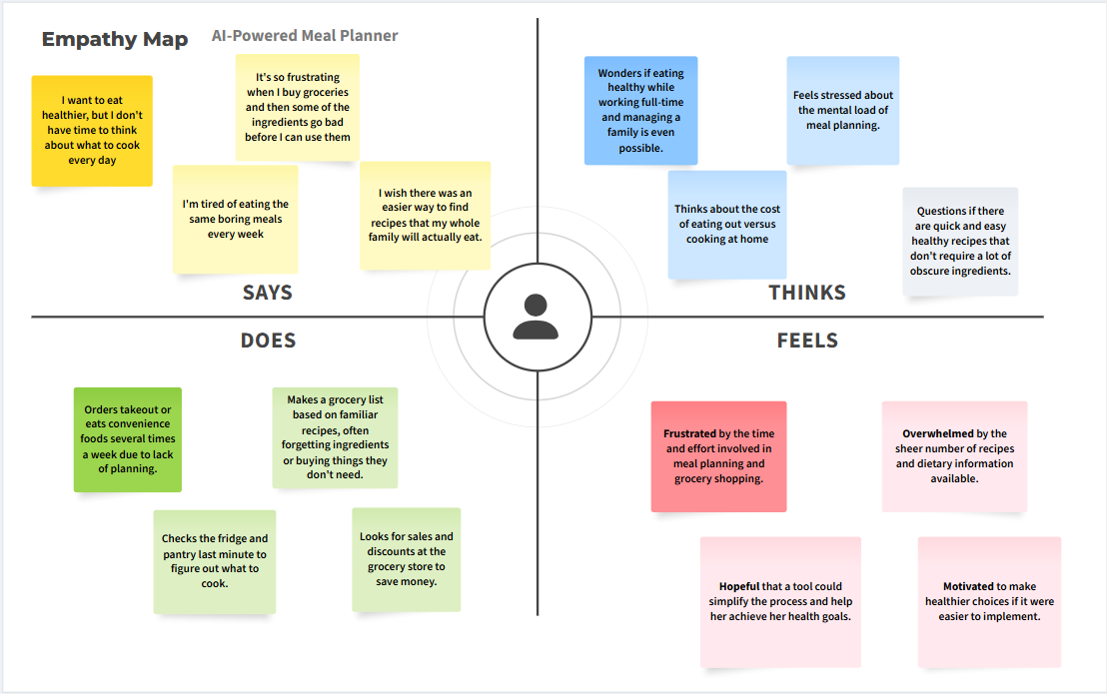

1. **Who is your Customer?**

**Description: This is where you specify the customer or user you are empathizing with. It could be a specific user persona or a general user segment.**

**Key points:**

* **Define the customer profile clearly (e.g., age, profession, interests).**
* **State their goals and needs related to the innovation or product.**
* **Context in which the user will interact with your solution.**

1. **Who are we empathizing with?**

**Description: This area helps you define who the user is, what their situation looks like, and what role they play. It emphasizes understanding the user’s perspective in depth.**

**Key points:**

* **Define the user's characteristics (e.g., personality, values, and responsibilities).**
* **State the user's goals and challenges in their environment.**
* **What is the user's broader situation (professionally or personally)?**

1. **What do they need to DO?**

**Description: This section identifies what actions or tasks the user needs to perform. It helps highlight the expectations and demands the user faces.**

**Key points:**

* **Clarify the tasks or actions the user needs to complete.**
* **What decisions do they need to make?**
* **How do they define success or failure in their tasks?**

1. **What do they SEE?**

**Description: This focuses on the visual stimuli or environment that the user interacts with. It's important to consider what users see in their immediate surroundings and in their larger world.**

**Key points:**

* **What do users see in their physical and digital environment?**
* **What trends or competitors do they notice?**
* **How do these visual elements influence their behavior?**

1. **What do they SAY?**

**Description: This section captures what the user might say in public, such as comments or feedback they give in conversations or on social media.**

**Key points:**

* **What might users express openly in conversation about their problems?**
* **How do they express their goals or frustrations?**
* **What are their words during customer interviews or feedback?**

1. **What do they DO?**

**Description: This section focuses on what the user does, the actual behaviors they exhibit, and actions they take in different situations.**

**Key points:**

* **What observable actions do users take?**
* **What habits or routines do they follow?**
* **What might users do to try and solve their problems?**

1. **What do they HEAR?**

**Description: This addresses what information the user receives from external sources, such as colleagues, media, or industry trends. It helps map the influences surrounding the user.**

**Key points:**

* **What are they hearing from peers, mentors, or the industry?**
* **What media or channels of information are they exposed to?**
* **Are there any strong influencers guiding their behavior?**

1. **What do they THINK and FEEL?**

**Description: This is one of the most insightful sections, addressing the internal emotions, concerns, and motivations of the user. It helps identify their deep-rooted feelings.**

**Key points:**

* **What are their fears, worries, and anxieties?**
* **What are their motivations and desires?**
* **How do their thoughts and feelings align with their actions?**

1. **Pains and Gains**

**Description: This section focuses on the user’s frustrations and their desired outcomes. It helps to frame the user’s challenges (pains) and the benefits they seek (gains).**

**Key points:**

* **What are the user’s main pain points?**
* **What would make their life easier or more fulfilling?**
* **What benefits do they hope to achieve from your product or solution?**

**8. Persona of Stakeholders**

**Stakeholder Name:**

**Demographics: Key characteristics of your target audience, such as age, gender, income, and location.**

**Goals: What the stakeholders or customers want to achieve in relation to the innovation.**

**Challenges: The obstacles or difficulties faced by stakeholders that the innovation aims to address.**

**Aspiration: The long-term desires or dreams of your target audience related to the innovation.**

**Needs: The essential requirements of your customers or stakeholders that must be met.**

**Pain Points: Specific problems or frustrations experienced by the target audience.**

**Storytelling: A narrative that highlights the journey of the stakeholder or customer, illustrating the problem and how the innovation can solve it.**

**Sample:**

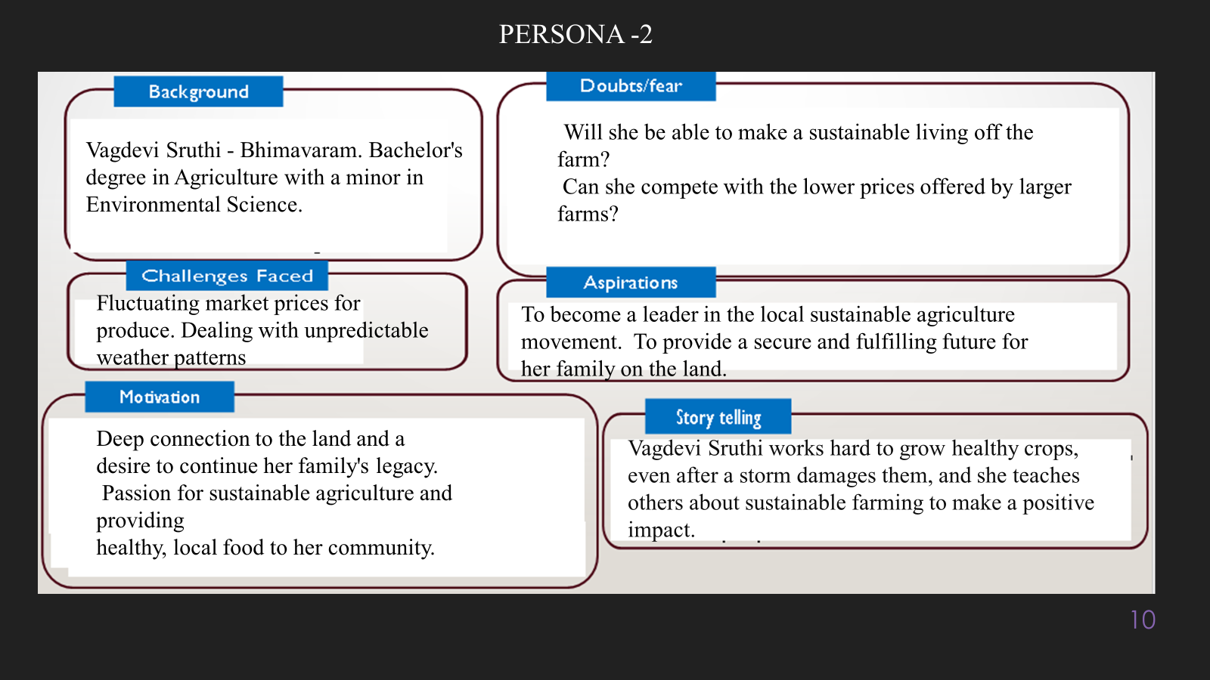

**10. Look for Common Themes, Behaviors, Needs, and Pain Points among the Users**

Analyse the data from your affinity diagram to uncover recurring patterns among your users, helping you better understand their expectations and challenges.

**Common Themes: Identify broad ideas or issues that repeatedly appear across different groups in your affinity diagram.**

**Common Behaviors: Observe how users consistently act or respond in relation to the problem or product throughout their journey.**

**Common Needs: Pinpoint essential requirements or desires that many users share, highlighting what they need for a better experience.**

**Common Pain Points: Look for frustrations or obstacles that frequently hinder the user experience, which your project can address.**

**12. Define Needs and Insights of Your Users**

**User Needs: Define the core requirements your users have in relation to the problem or product. These could be functional, emotional, or societal needs that your solution must address.**

**User Insights: Summarize the key understandings or observations you've uncovered about your users' behaviors, motivations, and pain points. These insights provide a deeper understanding of why users behave the way they do and what drives their decisions.**

**13. POV Statements**

**POV Statements:**

* [User] needs a way to [need] because [insight].

| **PoV Statements**  **(At least ten)** | **Role-based or Situation-Based** | **Benefit, Way to Benefit,**  **Job TBD,**  **Need (more/less)** | **PoV Questions**  **(At least one per statement)** |
| --- | --- | --- | --- |
| **(Erase this example) When I drive to work, I want to avoid traffic jams so I don’t get in trouble with my boss for being late.** | **A frequent online shopper** needs a way to **quickly identify trustworthy reviews** because they are tired of being misled by fake reviews. | Way to Benefit, Need (more) | What can we design that will enable shoppers to easily filter out fake reviews and focus on genuine feedback? |
|  | **A small business owner** needs a way to **protect their product reputation** because fake negative reviews are unfairly impacting their sales. | Way to Benefit, Need (more) | What can we design that will empower small business owners to effectively combat fake reviews and maintain a positive online image? |
|  |  |  |  |
|  |  |  |  |
|  |  |  |  |

**14. Develop POV/How Might We (HMW) Questions to Transform Insights/Needs into Opportunities for Design**

Turn your user needs and insights into actionable opportunities by framing them as "How Might We" (HMW) questions. These questions will spark creative problem-solving and guide your innovation process.

1. **How Might We: Based on the needs and insights you've identified, create open-ended questions starting with "How might we...?" These questions should aim to solve user pain points, enhance the experience, or address specific needs.**

**Examples:**

* **User Need: "Users need a quicker way to access customer support."**
  + **HMW Question: "How might we create a more efficient and accessible customer support system?"**

* **Insight: "Users feel overwhelmed by too many options."**
  + **HMW Question: "How might we simplify decision-making for our users?"**

**Task:**

**Write 3-5 "How Might We" questions based on your analysis of user needs and insights. These questions should challenge you to think of innovative solutions that can address user problems in meaningful ways.**

**This task encourages participants to think creatively about solving user problems, transforming challenges into opportunities for innovation.**

| **User Need/Insight** | **"How Might We" Question** |
| --- | --- |
| "Shoppers are overwhelmed by the sheer volume of reviews and struggle to quickly identify trustworthy ones." | **How might we...** help shoppers easily and quickly identify reliable reviews among a large number of them? |

**16. Crafting a Balanced and Actionable Design Challenge**

The Design Challenge Should Neither Be Too Narrow Nor Too Broad and It Should Be an Actionable Statement with a quantifiable goal. It should be a culmination of the POV questions developed.

**Design Challenge:** [Actionable Statement]

**17. Validating the Problem Statement with Stakeholders for Alignment**

Ensure your problem statement accurately represents the needs and concerns of your stakeholders and users. This involves gathering feedback from these groups to confirm that the problem is relevant and significant from their perspective. By validating early, you can refine the problem statement to better align with real-world challenges, ensuring your solution addresses the correct issues.

**Validation Plan:**

**Stakeholder/User Feedback (Min. 10 Stakeholders/Experts):**

| **Stakeholder/User** | **Role** | **Feedback on Problem Statement** | **Suggestions for Improvement** |
| --- | --- | --- | --- |
| Sarah Jones | Chefs | Value recipe quality and the ability to customize suggestions based on skill level and ingredients. | Makes cooking easier and more enjoyable, especially for less experienced cooks. |
| David Lee | Food Bloggers | Interested in unique recipe discovery and potential for recipe sharing within the platform. | Addresses the food waste concern and helps users save money. |

**18. Ideation**

**Ideation Process:**

| **Idea Number** | **Proposed Solution** | **Key Features/Benefits** | **Challenges/Concerns** |
| --- | --- | --- | --- |
| **Idea 1** | **"Trust Score" System:** Assign a numerical "trust score" to each review based on automated analysis. | Easy for users to understand review reliability at a glance. Increases transparency. | Defining a fair and accurate scoring algorithm. Potential for manipulation of the score. |
| **Idea 2** | **"Verified Purchase" Filter Enhancement:** Go beyond simple verification and analyze the purchase history of reviewers for patterns. | More robust verification of genuine buyers. Reduces fake reviews from unverified accounts. | Privacy concerns related to accessing purchase data. Complexity of analyzing purchase patterns. |
| **Idea 3** | **Language Pattern Detector":** Focus solely on analyzing the text of reviews for telltale signs of fake reviews, such as repetitive phrases or overly emotional language. | Quick and efficient detection of many fake reviews. Relatively low resource requirements. | Easily bypassed by sophisticated fake review writers. Potential for false positives (flagging genuine, but poorly written, reviews). |
| **Idea 4** | **["Community Reporting & Voting":** Allow users to flag suspicious reviews and let the community vote on their validity. | Leverages the collective intelligence of users. Increases user engagement. | Susceptible to manipulation by organized groups. Potential for biased voting. Requires moderation to prevent abuse. |
| **Idea 5** | **"Reviewer Behavior Analysis":** Track reviewer activity across multiple platforms and identify suspicious patterns, such as sudden bursts of reviews or inconsistent ratings. | Provides a more comprehensive view of reviewer credibility. Helps detect networks of fake reviewers. | Requires access to data from multiple platforms. Privacy concerns related to tracking user activity. |

**18. Idea Evaluation**

Evaluate the Idea based on 10/100/1000 grams

| **Idea** | **Impact (10/100/1000 grams)** | **Feasibility (10/100/1000 grams)** | **Alignment (10/100/1000 grams)** | **Total Weight** |
| --- | --- | --- | --- | --- |
| Fake Review Monitoring System | 800 | 600 | 900 | 2300 |
| Personalized Product Recommendations | 700 | 700 | 800 | 2200 |
| AI-Powered Customer Service Chatbot | 600 | 800 | 700 | 2100 |
| Enhanced Product Image Search | 500 | 900 | 600 | 2000 |
| Real-Time Price Comparison Tool | 850 | 500 | 750 | 2100 |

**Example:**

| **Idea** | **Impact (10/100/1000 grams)** | **Feasibility (10/100/1000 grams)** | **Alignment (10/100/1000 grams)** | **Total Weight** |
| --- | --- | --- | --- | --- |
| **Idea 1** | **1000** | **100** | **1000** | **2100** |
| **Idea 2** | **100** | **1000** | **100** | **1200** |
| **Idea 3** | **100** | **100** | **100** | **300** |

Further, use solution concept form to scrutinize the idea

**Solution Concept Form**

**1. Problem Statement:**

Many people struggle with the daily challenge of deciding what to eat, planning meals, and shopping for groceries. This often leads to unhealthy choices, wasted food, and a lot of unnecessary stress and time spent. Figuring out what to cook that's healthy, fits everyone's needs, and doesn't take forever is a common pain point we aim to solve.

**2. Target Audience:**

∙ Our ideal users are people who want to eat healthier, save time and money on groceries, or simply make meal planning easier. This includes busy professionals, families juggling work and kids, individuals with specific dietary needs, and anyone tired of the daily "what's for dinner?" question. Essentially, it's for anyone looking for a smarter, simpler way to manage their meals.

**3. Solution Overview:**

Our AI-powered meal planner is like a smart assistant for your kitchen. You tell it what you like, your dietary needs, and what food you have. Then, it uses smart technology to suggest recipes, create weekly meal plans, and even make your grocery shopping list. It learns your preferences over time, making meal planning faster, healthier, and less wasteful. Think of it as having a personal food expert in your pocket, simplifying everything from inspiration to cooking.

**4. Key Features:**

| **Feature** | **Description** |
| --- | --- |
| Personalized Meal Plans | Tailors meals to user’s taste, health goals, and diet needs |
| Smart Recipe Suggestions | Recommends recipes based on available ingredients |
| Nutrition Tracking | Monitors calorie and nutrient intake |

**5. Benefits:**

| **Benefit** | **Description** |
| --- | --- |
| Healthy Eating | Encourages balanced and nutritious meals |
| Time Saving | Reduces time spent on meal planning and searching recipes |
| Personalized Plans | Offers meal suggestions based on user preferences and needs |

**6. Unique Value Proposition (UVP):**

**Tired of the daily dinner dilemma? Our AI-powered meal planner takes the stress out of eating well. Imagine having personalized meal plans created just for you, along with smart grocery lists that make shopping a breeze. Our AI learns what you like, considers your dietary needs, and even helps you use up what's already in your kitchen. Say goodbye to meal planning headaches and hello to delicious, effortless meals with our intelligent AI companion.**

**7. Key Metrics:**

| **Metric** | **Measurement** |
| --- | --- |
| User Engagement | Number of active users and how often they use it |
| Meal Plan Accuracy | Satisfaction with meal suggestions |

**8. Feasibility Assessment:**

∙ We have the computer power and smart programs (AI) needed.

· We can get the review data to analyze.

· We can keep improving the system as fake reviews get trickier.

**9. Next Steps:**

Our next steps are:

* Build a test version of the system.
* Train it with real review data.
* Test how well it finds fake reviews.
* Get feedback from users.
* Make it better and launch it.